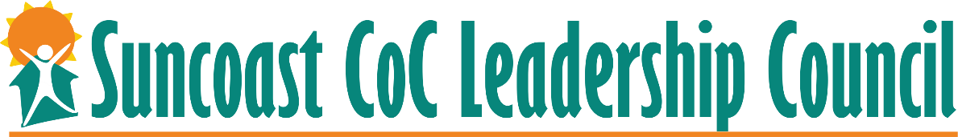

FY19 CoC Program Competition Priority Listing

Rank | Applicant Name | Project Name | Project Component | Type | Score | Amount | Previous Year | Updated 9/23/19*
1 | Suncoast Partnership | HMIS | HMIS | Renewal | N/A | $74,575.00 | $74,575.00
2 | Catholic Charities |  | PSH to TH/RRH | Transition | N/A | $83,275.00 | $83,275.00
3 | Salvation Army Sarasota | Everyone's Home | RRH | Renewal | 96 | $221,919.00 | $221,919.00
4 | Salvation Army Sarasota | Everyone's Home 2 | RRH | Renewal | 96 | $85,113.00 | $85,113.00
5 | St. Vincent de Paul CARES |  | RRH | New | 92 | $250,006.00
6 | Suncoast Partnership | Coordinated Entry | SSO-CE | New | N/A | $50,006.00
7 | CASL | FL500 Bonus, CASL | PSH | Renewal | 63 | $89,343.00 | $77,544.00 | 100,344.00
8 | Salvation Army Sarasota |  | PSH | New | 88 | $371,174.00 |  | 371,714.00
9 | St. Vincent de Paul CARES | DV Bonus | RRH | DV Bonus | 84 | $282,251.00
10 | Harvest House |  | PSH | Renewal | 83 | $113,400.00 | $131,120.00 | 131,120.00
Ranking of projects is based on HUD policy priorities and expectations with review and oversight of renewal and new projects as found in the FY 19 CoC Program Competition NOFA, as well as local priorities as adopted from the report by the Florida Housing Coalition, Creating an Effective Homeless Crisis Response System and established by the Leadership Council.
*There were additional dollars available in bonus funds due to a miscalculation; they were added per Review and Rank committee as reflected in the updated column.

